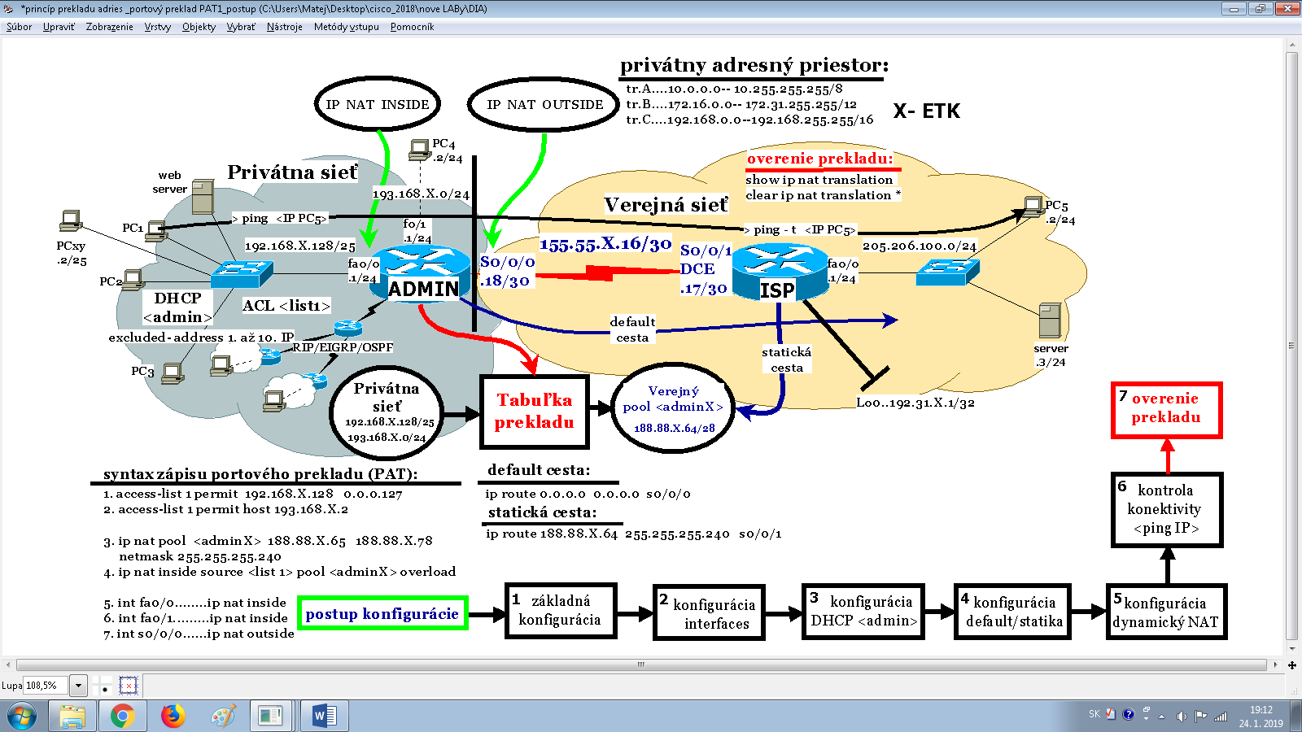

**ip access-list standard PAT**

**permit 192.168.X.128 0.0.0.127**

**permit 192.168.X.0 0.0.0.255**

**ip nat inside source list PAT interface s0/0/0 overload**

